**SYDNEY WESTERN CITY PLANNING PANEL ASSESSMENT REPORT**

|  |  |
| --- | --- |
| Panel Number: | PPSSWC-267. |
| Application Number: | DA/2022/860/1. |
| Local Government Area: | Camden. |
| Development: | Construction of a two storey classroom building, outdoor amphitheatre, COLA and associated works at Oran Park Anglican School. |
| Capital Investment Value: | $6,409,034 |
| Site Address(es): | 60 Central Avenue ORAN PARK  Lot: 15 DP: 1153031. |
| Applicant: | Warren Fletcher – Gardner Wetherill Butler and Co Architects. |
| Owner(s): | The Anglican Schools Corporation. |
| Date of Lodgement: | 16 September 2022. |
| Number of Submissions: | Nil. |
| Number of Unique Objections: | Nil. |
| Classification: | Local. |
| Recommendation: | Approve with conditions. |
| Regional Development Criteria (Schedule 7 of State Environmental Planning Policy (State and Regional Development) 2011): | Community facility (educational establishment) and >$5 million CIV |
| List of All Relevant Section 4.15(1)(a) Matters: | * State Environmental Planning Policy (Planning Systems) 2021. * State Environmental Planning Policy (Precincts - Western Parkland City) 2021. * State Environmental Planning Policy (Resilience and Hazards) 2021. * State Environmental Planning Policy (Transport and Infrastructure) 2021. * State Environmental Planning Policy (Biodiversity and Conservation) 2021. * Oran Park Development Control Plan 2007. * Camden Development Control Plan 2019. |
| List all Documents Submitted with this Report for the Panel’s Consideration: | * Assessment report. * State Environmental Planning Policy (Precincts - Western Parkland City) 2021 assessment table. * State Environmental Planning Policy (Transport and Infrastructure) 2021 assessment table. * Recommended conditions. * Proposed plans. |
| Development Standard Contravention Request(s): | Nil. |
| Summary of Key Submission Issues: | Nil. |
| Report Prepared By: | Nicholas Clarke, Senior Town Planner. |
| Report Date: | December 2022. |

**Summary of Section 4.15 Matters**

|  |  |
| --- | --- |
|  | **Yes** |
| Have all recommendations in relation to relevant Section 4.15 matters been summarised in the Executive Summary of the assessment report? |  |

**Legislative Sections Requiring Consent Authority Satisfaction**

|  |  |
| --- | --- |
|  | **Yes** |
| Have relevant sections in all applicable environmental planning instruments where the consent authority must be satisfied about a particular matter been listed and relevant recommendations summarised in the Executive Summary of the assessment report? |  |

**Development Standard Contraventions**

|  |  |  |
| --- | --- | --- |
|  | **Yes** | **N/A** |
| If a written request for a contravention to a development standard has been received, has it been attached to the assessment report? |  |  |

**Special Infrastructure Contributions**

|  |  |  |
| --- | --- | --- |
|  | **Yes** | **No** |
| Does the application require Special Infrastructure Contributions? |  |  |

**Conditions**

|  |  |
| --- | --- |
|  | **Yes** |
| Have draft conditions been provided to the applicant for comment? |  |

**PURPOSE OF REPORT**

The purpose of this report is to seek the Sydney Western City Planning Panel’s (The Panel’s) determination of a development application (DA) for a school building and COLA at 60 Central Avenue, Oran Park.

The Panel is the consent authority for this DA as the capital investment value (CIV) of the development is $6,409,034. This exceeds the CIV threshold of $5 million for private infrastructure or community facilities for Council to determine the DA pursuant to Schedule 7 of State Environmental Planning Policy (Planning Systems) 2021.

**SUMMARY OF RECOMMENDATION**

That the Panel determine DA/2022/860/1 for a school building and COLA pursuant to Section 4.16 of the *Environmental Planning and Assessment Act, 1979,* by granting consent subject to the conditions attached to this report.

**EXECUTIVE SUMMARY**

Council is in receipt of a DA for construction of a two storey classroom building, outdoor amphitheatre, COLA and associated works at Oran Park Anglican School located at 60 Central Avenue Oran Park.

The DA has been assessed against the *Environmental Planning and Assessment Act 1979*, the *Environmental Planning and Assessment Regulation, 2021*, relevant environmental planning instruments, development control plans and policies.

A summary of the assessment of all relevant environmental planning instruments is provided below with a detailed assessment provided later in the report.

|  |  |
| --- | --- |
| State Environmental Planning Policy (Planning Systems) 2021. | The Panel is the consent authority for this DA as the development has a CIV of $6,409,034 which exceeds the CIV threshold of $5 million (private infrastructure or community facility) for Council to determine the DA. |
| State Environmental Planning Policy (Precincts - Western Parkland City) 2021 (Western Parkland City SEPP). | The development is permitted with consent in the applicable R3 Medium Density Residential zone, is consistent with the zones’ objectives and acceptable in terms of the Western Parkland City SEPP’s other matters for consideration. |
| State Environmental Planning Policy (Transport and Infrastructure) 2021 (Transport and Infrastructure SEPP). | The proposed development is permissible under the Transport and Infrastructure SEPP. The new school building is considered to represent a high-quality design and architectural presence, that is in accordance with the design principles prescribed under Schedule 8 of the SEPP.  The DA was referred to Transport for NSW for comment pursuant to the Transport and Infrastructure SEPP and the comments received have been considered. |
| State Environmental Planning Policy (Resilience and Hazards) 2021 (Resilience and Hazards SEPP). | The Resilience and Hazards SEPP requires the consent authority to be satisfied that the site is suitable for its intended use (in terms of contamination) prior to granting consent.  A detailed assessment against the relevant matters contained against former State Environmental Planning Policy No. 55 – Remediation of land was considered with the parent subdivision and school approval.  Therefore, standard conditions will apply to ensure ongoing compliance with the approved measures under the parent application. Council staff are satisfied that the site is suitable for the development. |
| State Environmental Planning Policy (Biodiversity and Conservation) 2021 (Biodiversity and Conservation SEPP). | The development is consistent with the aim of the Biodiversity and Conservation SEPP (to protect the environment of the Hawkesbury-Nepean River system) and all of its planning controls. |

The DA was publicly exhibited for a period of 14 days in accordance with Camden Community Participation Plan 2021. The exhibition period was from 11 to 25 October 2022 and no submissions were received.

The development has been assessed against State Environmental Planning Policy (Precincts - Western Parkland City) 2021, State Environmental Planning Policy (Transport and Infrastructure) 2021, Oran Park Development Control Plan 2007 and Camden Development Control Plan 2019. The development is consistent with these planning policies and controls.

Part 3.4, Clause 3.36(9), of the State Environmental Planning Policy (Transport and Infrastructure) 2021 states that any provision of a development control plan (such as the Camden DCP 2019 and Oran Park DCP 2007) has no effect, regardless of when the development control plan was made. Therefore, the controls of the Camden DCP 2019 and Oran Park DCP 2007 do not apply to the site. However, it is noted that the proposal is consistent with the objectives and controls contained within both DCPs subject to recommended conditions.

The proposed development does not propose a change to the existing approved staff/student numbers for the school. The maximum number remains consistent with the masterplan consent being 1286 students and 110 staff.

Given there is no increase to the number of staff or students, no additional car parking is required as part of this development. The existing car park remains on-site in accordance with the car parking staging plan approved under the Master Plan concept DA/2012/927/1.

The applicant has submitted an adequate stormwater management strategy that, subject to the attached conditions, will provide adequate stormwater management. Based on the assessment, it is recommended that the DA be approved subject to the conditions attached to this report.

**AERIAL PHOTO**

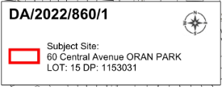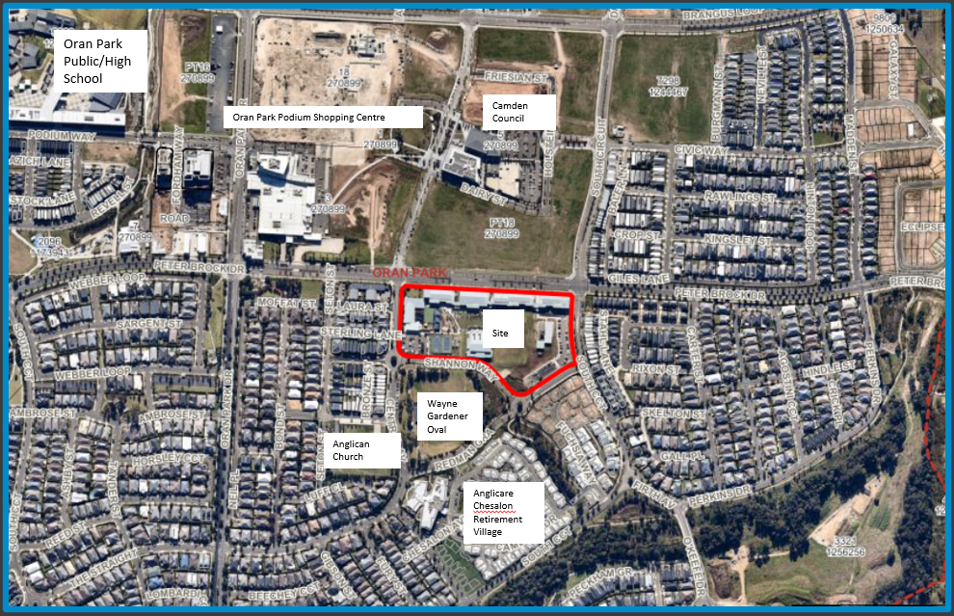

Figure 1: Aerial Photo and Surrounding Context

**THE SITE**

The subject site is commonly known as Oran Park Anglican College which is located at 60 Central Avenue Oran Park. The site is legally described as Lot: 15 DP: 1153031. The development application proposes the construction of a two storey classroom building, outdoor amphitheatre, covered outdoor learning area (COLA) and associated works within the approved Oran Park Anglican College campus.

The school site is centrally located within the Oran Park Precinct, nearby to Oran Park Town Centre. The site is adjacent to land zoned for retail, leisure, civic, residential and mixed-use purposes. The site is bound by Peter Brock Drive to the north, South Circuit to the east, Sharman Way/Redman Grange to the south and Central Avenue to the west. Existing access to the site is provided from South Circuit, Sharman Way/Redman Grange and Central Avenue.

Within the school site, Building 8 is proposed to be located at the south-eastern corner of the site with direct frontage to Redman Grange and South Circuit. The land slopes from north to south with a fall of approximately 2 metres within the building footprint.

The site is zoned as R3 – Medium Density Residential under State Environmental Planning Policy (Precincts - Western Parkland City) 2021. The proposed new building does not alter the existing use on site as an educational establishment.

**ZONING PLAN**

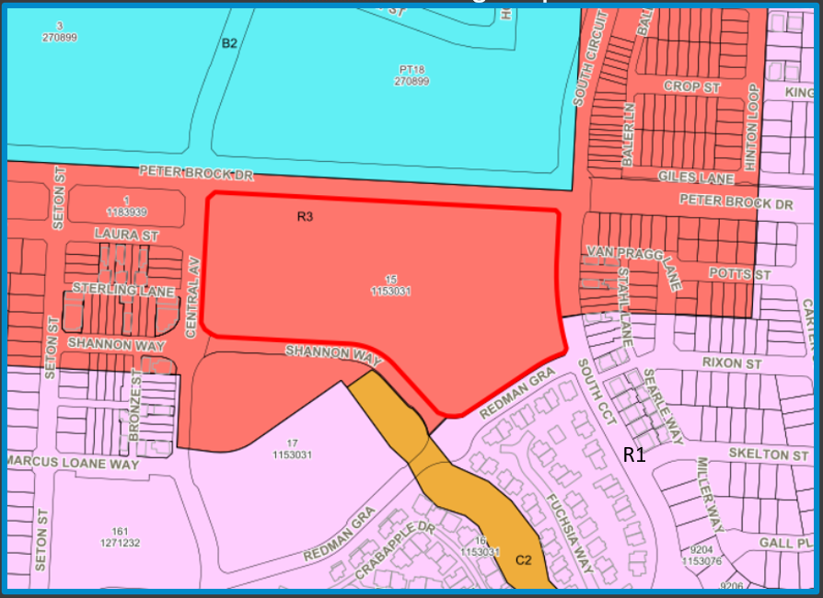

*Figure 2: Land Zoning Map – R3 – Medium Density Residential*

**MASTERPLANS**

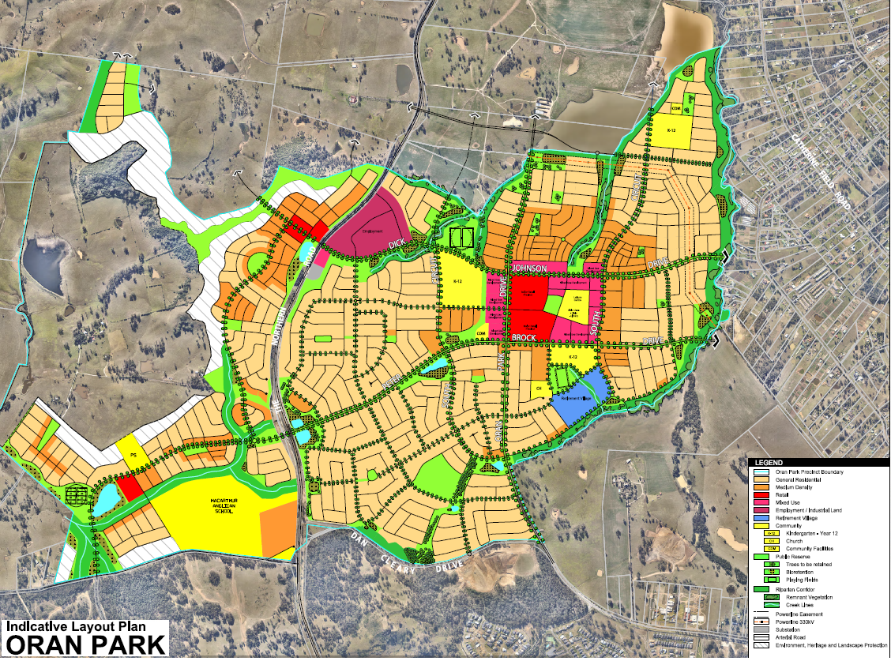

Figure 3: Oran Park Indicative Layout Plan

**BACKGROUND**

The relevant development background of the site is summarized in the table below:

|  |  |
| --- | --- |
| **Application No.** | **Development** |
| DA/2007/982/1 | Creation of the subject site as a residue lot. |
| DA/2010/680/1 | Approval of the primary school campus for the Oran Park Anglican College (for 120 students and 9 staff from K to Year 3), including the construction of 33 parking spaces. |
| DA/2010/680/(2) | Modification to allow the operation of the school up to Year 6, with no increase to approved student numbers. |
| DA/2010/680/(3) | Modification to allow the operation of the school up to Year 7 with an increase of staff to 11 and installation of six temporary demountable classrooms for 2 years. |
| DA/2010/680/(4) | Modification to relocate the six demountable classrooms. |
| DA/2012/927/1 | Approval of a staged development for the primary and secondary school for the Oran Park Anglican College (for 986 students). The DA also approved the construction of “Building 2A”, playground, stormwater detention, and road works. |
| DA/2015/1394/1 | Construction of a two-storey school building including landscaping. The DA involved the construction of “Building 4” in accordance with the approved staged development consent (DA 927/2012). The proposal is in accordance with the approved masterplan as part of the staged consent. |
| DA/2016/1164/1 | Construction of the multi-purpose hall (Building 9), no increase in student numbers or car parking was associated with this development. |
| DA/2017/1250/1 | Construction of a new two storey school building (Building 3) incorporating classrooms, staff and student services. |
| DA/2019/987/1 | Construction of a new two-storey school building at Oran Park Anglican School. |
| DA/2021/1424/1 | Construction of an administration building and establishment of a new school entry on the Shannon Way frontage with associated site works including civil, landscaping and drainage works. |

The subject land has been approved for the staged development of a Kindergarten to Year 12 educational establishment.

Previous development application DA/2010/680/1 was approved for the primary school campus of the Oran Park Anglican College, which included the construction of four (4) primary school classrooms, six (6) temporary demountable buildings, carpark, drop-off area, playground and support facilities.

A further development application was approved under DA/2012/927/1 (and subsequent S4.55 modifications) for the staged development of the high school campus of the Oran Park Anglican College. The consent approved a Master Plan which specified that separate development applications are to be lodged for each stage. The consent approved the staged concept development of the school as well as the construction of Building 8 and an amphitheatre.

Since the approval of the staged Master Plan, the school site has undergone orderly development generally in accordance with the approved Master Plan for the site.

The proposed development remains in accordance with Section 4.22 of the *Environmental Planning and Assessment Act, 1979*, in that it conforms to the “concept development application” master plan approved under DA/2012/927/1.

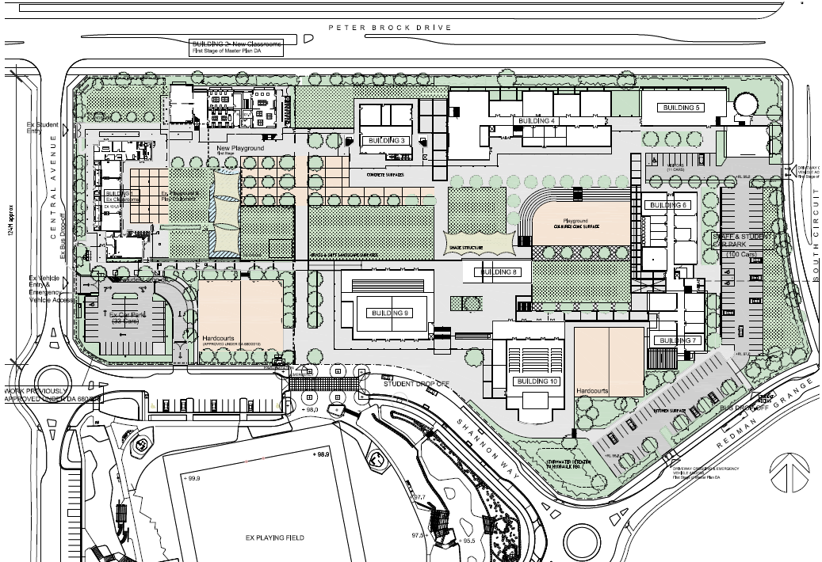*Figure 4: Master Plan approved under DA/2019/927/1*

**THE PROPOSAL**

The application is seeking approval for the construction of a two storey classroom building, outdoor amphitheatre, COLA and associated works at Oran Park Anglican College. Specifically, this includes:

* The ground floor comprises of student amenities, four performing arts rooms, an office, break out space and rehearsal area at the eastern end of the building.
* At the first-floor level there are student amenities and six general learning areas (GLA’s) adjoining a central breakout area.
* Upgrade of the basketball court with amphitheatre seating and a metal covered outdoor learning area structure with aluminium weather louvres at the upper level, and a skillion roof with Colourbond metal roof sheeting.
* Landscaping is proposed to the north, south and west of the basketball court and to the east and south of proposed Building 8, between the building and existing car park area.

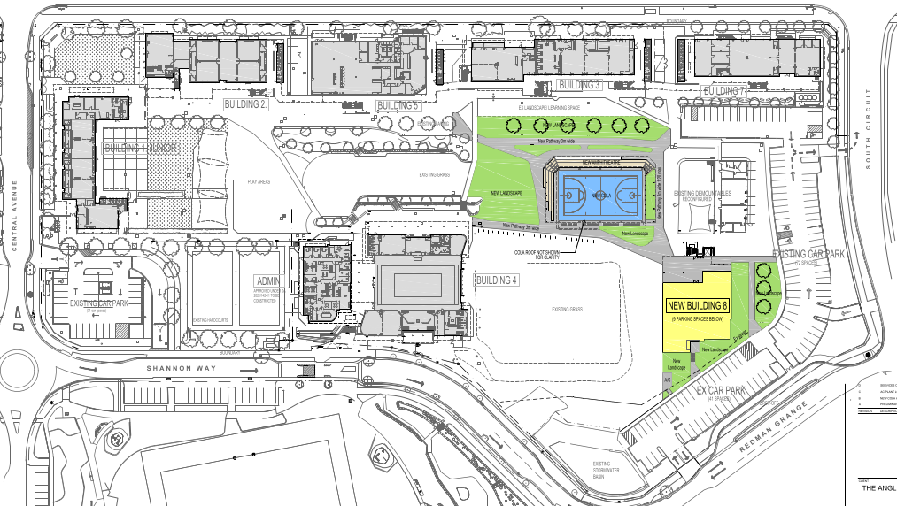

Figure 5: Site Plan

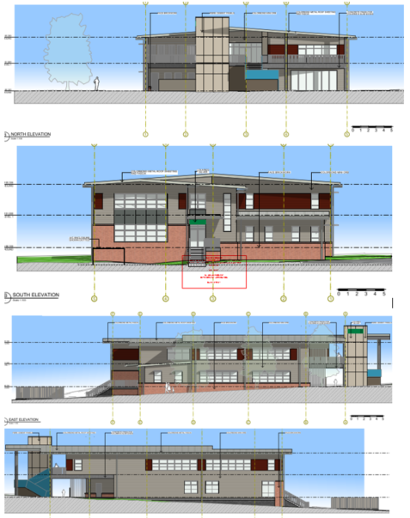

Figure 6: Building 8 Elevations and External Finishes

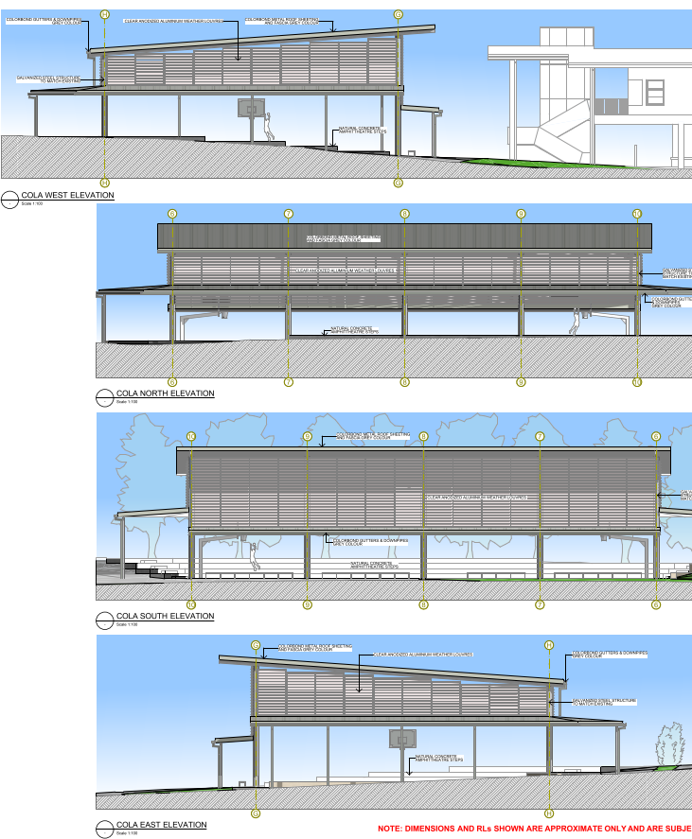

Figure 7: COLA Elevations and External Finishes

**PANEL Briefing**

Council staff briefed the Panel on the DA on 7 November 2022. The following discussion provides an assessment of how the issues raised by the Panel at the briefing have been addressed:

1. *Urban Design Advice*

At the Panel’s request during the ‘Kick-off’ briefing, the application was referred to Council’s Urban Design advisor for comment regarding the proposed design of the school building.

Council’s Urban Design Adviser raised no issue with the proposed works subject to the design being accessible by all the potential users and the roof colour grey being of a light shade to minimise the urban heat island effect. Conditions of consent have been imposed to ensure the proposed roofing colour matches that of the existing buildings within the site.

**ASSESSMENT**

***Environmental Planning and Assessment Act 1979 – Section 4.15(1)***

In determining a DA, the consent authority is to take into consideration such of the following matters as are of relevance to the development the subject of the DA:

***(a)(i) the provisions of any environmental planning instrument***

The environmental planning instruments that apply to the proposed development are:

* State Environmental Planning Policy (Planning Systems) 2021.
* State Environmental Planning Policy (Precincts - Western Parkland City) 2021.
* State Environmental Planning Policy (Transport and Infrastructure) 2021.
* State Environmental Planning Policy (Resilience and Hazards) 2021.
* State Environmental Planning Policy (Biodiversity and Conservation) 2021.

State Environmental Planning Policy (Planning Systems) 2021 (Planning Systems SEPP)

The Planning Systems SEPP identifies development that is State significant and regionally significant development.

Pursuant to Schedule 7 of the SEPP, the Panel is the determining authority for this DA as the proposed development has a CIV of $6,409,034 which exceeds the CIV threshold of $5 million (private infrastructure or community facility) for Council to determine the DA.

State Environmental Planning Policy (Precincts - Western Parkland City) 2021 (Western Parkland City SEPP)

The Western Parkland City SEPP aims to co-ordinate the release of land for residential, employment and other urban development in the North West Growth Centre, the South West Growth Centre, the Wilton Growth Area and the Greater Macarthur Growth Area.

*Site Zoning*

The site is zoned as R3 – Medium Density Residential under State Environmental Planning Policy (Precincts - Western Parkland City) 2021.

*Development Characterisation*

The development is characterised as an “educational establishment” by the Western Parkland City SEPP.

*Permissibility*

The development is permitted with consent in the zone in which it is proposed pursuant to the land use table in Appendix 2 of the Western Parkland City SEPP.

*Planning Controls*

An assessment table in which the development is considered against the Western Parkland City SEPP’s planning controls is provided as an attachment to this report.

State Environmental Planning Policy (Transport and Infrastructure) 2021 (Transport and Infrastructure SEPP)

The Transport and Infrastructure SEPP aims to facilitate the effective delivery of educational establishments and early education and care facilities across the State and applies to the subject development being for the purpose of a ‘educational establishment’.

Clause 3.36 of the SEPP outlines the development controls for schools where development is permitted with consent. Under the provisions of Clause 3.36(2), the proposed new school structures within the boundaries of the existing school are permitted with development consent.

An assessment table in which the development is considered against the Transport and Infrastructure SEPP’s planning controls is provided as an attachment to this report.

With reference to Clause 3.36(6) of the SEPP, the proposed development has been assessed against the design principles set out under Schedule 8 of the SEPP. The new school building and associated structures are considered to represent a high-quality design and architectural presence, that is compliant with the design principles prescribed under Schedule 8.

*Transport for NSW (TfNSW)*

The DA was referred to TfNSW for comment pursuant to Section 3.58 Traffic Generating Developmentof the Transport and Infrastructure SEPP as the development is for the purpose of an educational establishment able to accommodate 50 or more additional students and involves an extension of existing premises that has direct access to a road.

TfNSW has reviewed the proposal and has not specified any requirements, as they consider that the proposed development will have a negligible impact on the classified arterial road network.

State Environmental Planning Policy (Resilience and Hazards) 2021 (Resilience and Hazards SEPP)

The Resilience and Hazards SEPP requires the consent authority to be satisfied that the site is suitable for its intended use (in terms of contamination) prior to granting consent.

A detailed assessment against the relevant matters contained against former State Environmental Planning Policy No. 55 – Remediation of land was considered with the parent subdivision and school approval. Therefore, standard conditions will apply to ensure ongoing compliance with the approved measures under the parent application. Council staff are satisfied that the site is suitable for the proposed development.

State Environmental Planning Policy (Biodiversity and Conservation) 2021 (Biodiversity and Conservation SEPP)

The Biodiversity and Conservation SEPP aims to protect the environment of the Hawkesbury-Nepean River system by ensuring that the impacts of future land uses are considered in a regional context.

The development is consistent with the aim of the Biodiversity and Conservation SEPP and all of its planning controls. There will be no detrimental impacts upon the Hawkesbury-Nepean River system as a result of the development. Appropriate erosion, sediment and water pollution control measures have been proposed as part of the development.

***(a)(ii) the provisions of any proposed instrument that is or has been the subject of public consultation under this Act and that has been notified to the consent authority (unless the Secretary has notified the consent authority that the making of the proposed instrument has been deferred indefinitely or has not been approved)***

Draft Environment State Environmental Planning Policy (Draft Environment SEPP)

The development is consistent with the Draft Environment SEPP in that there will be no detrimental impacts upon the Hawkesbury-Nepean River system as a result of it.

Draft Remediation of Land State Environmental Planning Policy (Draft Remediation of Land SEPP)

The development is consistent with the Draft Remediation of Land SEPP in that it is consistent with the Resilience and Hazards SEPP.

***(a)(iii) the provisions of any development control plan***

Pursuant to Part 3.4, Clause 3.36(9), of the State Environmental Planning Policy (Transport and Infrastructure) 2021 any provision of a development control plan (such as the Camden DCP 2019 and Oran Park DCP 2007) has no effect, regardless of when the development control plan was made. Therefore, the controls of the Camden DCP 2019 and Oran Park DCP 2007 do not apply to the site. However, it is noted that the proposal is consistent with the objectives and controls contained within both DCPs subject to recommended conditions.

Issues ordinarily considered under these DCPs relating to environmental management, erosion and sedimentation, salinity, water management, waste management, acoustics, and parking are considered elsewhere within this report or are addressed via recommended conditions of consent.

***(a)(iiia) the provisions of any planning agreement that has been entered into under section 7.4, or any draft planning agreement that a developer has offered to enter into under section 7.4***

The Oran Park Voluntary Planning Agreement (VPA) applying to the land was executed on 22 September 2011. Clause 1.1 of the VPA excludes the subject site known as the ‘school land’ from the application of the agreement.

***(a)(iv) the regulations (to the extent that they prescribe matters for the purposes of this paragraph)***

The *Environmental Planning and Assessment Regulation, 2021* prescribes several matters that are addressed in the conditions attached to this report.

***(b) the likely impacts of the development, including environmental impacts on both the natural and built environments, and social and economic impacts in the locality***

As demonstrated by the above assessment, the proposed development is unlikely to have a significant negative impact on either the natural or built environments, or the social and economic conditions in the locality.

Stormwater Management

A stormwater concept plan was provided as well as a stormwater statement. There is currently a stormwater detention and treatment basin located at the south end of the site which services the stormwater from the school.

The stormwater from both structures is shown to connect into existing pipes which then flow into the basin. The existing basin has been designed to cater for these additions as per the masterplan for the site and is supported by Councils Development Engineer subject to standard conditions.

Parking

No changes to the number of students or staff is proposed by this application. As such no additional car parking is required (or proposed) under this application. It is noted that car parking has been provided as part of previous applications as per the car parking staging plan approved under the Master Plan concept DA/2012/927/1.

***(c) the suitability of the site for the development***

As demonstrated by the above assessment, the site is considered to be suitable for the proposed development.

***(d) any submissions made in accordance with this Act or the regulations***

The DA was publicly exhibited for a period of 14 days in accordance with Camden Community Participation Plan 2021. The exhibition period was from 11 to 25 October 2022 and no submissions were received.

***(e) the public interest***

The public interest is served through the detailed assessment of this DA under the *Environmental Planning and Assessment Act, 1979*, the *Environmental Planning and Assessment Regulation, 2021*, environmental planning instruments, development control plans and policies. Based on the assessment, the development is consistent with the public interest.

**EXTERNAL REFERRALS**

The external referrals undertaken for this DA are summarized in the following table:

|  |  |
| --- | --- |
| **External Referral** | **Response** |
| Transport for NSW | No objection and no recommended conditions. |

**FINANCIAL IMPLICATIONS**

This matter has no direct financial implications for Council.

**CONCLUSION**

The DA has been assessed in accordance with Section 4.15(1) of the *Environmental Planning and Assessment Act, 1979* and all relevant instruments, plans and policies. The DA is recommended for approval subject to the conditions attached to this report.

**RECOMMENDED**

**That the Panel approve DA/2022/860/1 for the construction of a two storey classroom building, outdoor amphitheatre, COLA and associated works at Oran Park Anglican School at 60 Central Avenue, Oran Park subject to the conditions attached to this report.**